**Course Project Report**

**CSI4999: Senior Capstone**

AFR

Alzheimer's Facial Recognition App

___________________________________

Robert Turczyn | Gabriel Thomas | Jacob Carpenter | Irald Kollcinaku | Zilin Li | Tyler Schauss

Version History

|  |  |  |  |
| --- | --- | --- | --- |
| Version | Implemented Section | Implemented  by | Details/Comments |
| 1.0 | Project Description and Requirements | Whole Team | Vision statement, Objectives, and Requirements laid out |

Table of Contents

I. Glossary of Key Terms  
II. Project Description  
A. Project statement  
B. Objectives  
D. Technologies & tools

E. Process model & schedule

III. Requirements  
A. Functional requirement

B. Non-Functional requirement

C. User Stories

IV. Design

A. Use Cases

1. *Glossary of Key Terms*

Client: Patient suffering from Alzheimer

Caretaker: Any person that takes care of or is closely involved with the client

DB: Database

TTS: Text to speech

AFR: Alzheimer’s Facial Recognition

AWS: Amazon Web Services

PWA: Progressive Web Application

1. *Project Description*

**A. Vision Statement**

**B. Objectives**

* Setup an AWS hosted server
  + Will host MySQL Database
    - Will hold data for client’s contacts
    - Will hold images of client’s contacts
* Use the device camera to achieve facial recognition
* Utilize text to speech to upon facial recognition
  + Will tell client the recognized contact’s information
* Allow clients to upload images and data of contacts
* Allow caretakers to upload images and informations that is connected to a client’s account
* Use PWA to create a web portal as well as Android and iOS apps
* Possible implement a location setting that can show the location of a client to a caretaker.

**C. Target Environment**

This application will be designed as a progressive web application (PWA). This means it will be a bootstrap web application that can also be easily implemented as an Android and iOS apps. This PWA app can also be made available to be downloaded in the Google Playstore and Apple App Store as a normal application. Designing the app in this way will save time since we will not have to make a separate port for the Android and iOS compatible apps as well as a web portal.

**D. Technology and Tools**

OpenCV will be the python library used for facial recognition. The applications themselves will be PWA. That includes using HTML, CSS, JavaScript, and possible PHP. The development environments we will use to code this project will be Visual Studio 2017 and Android studio if needed for Android port. To track what group members will be working on what we will be using Asana and all files and projects will be uploaded to a Google Team Drive as well as Github.

**E. Project Schedule**

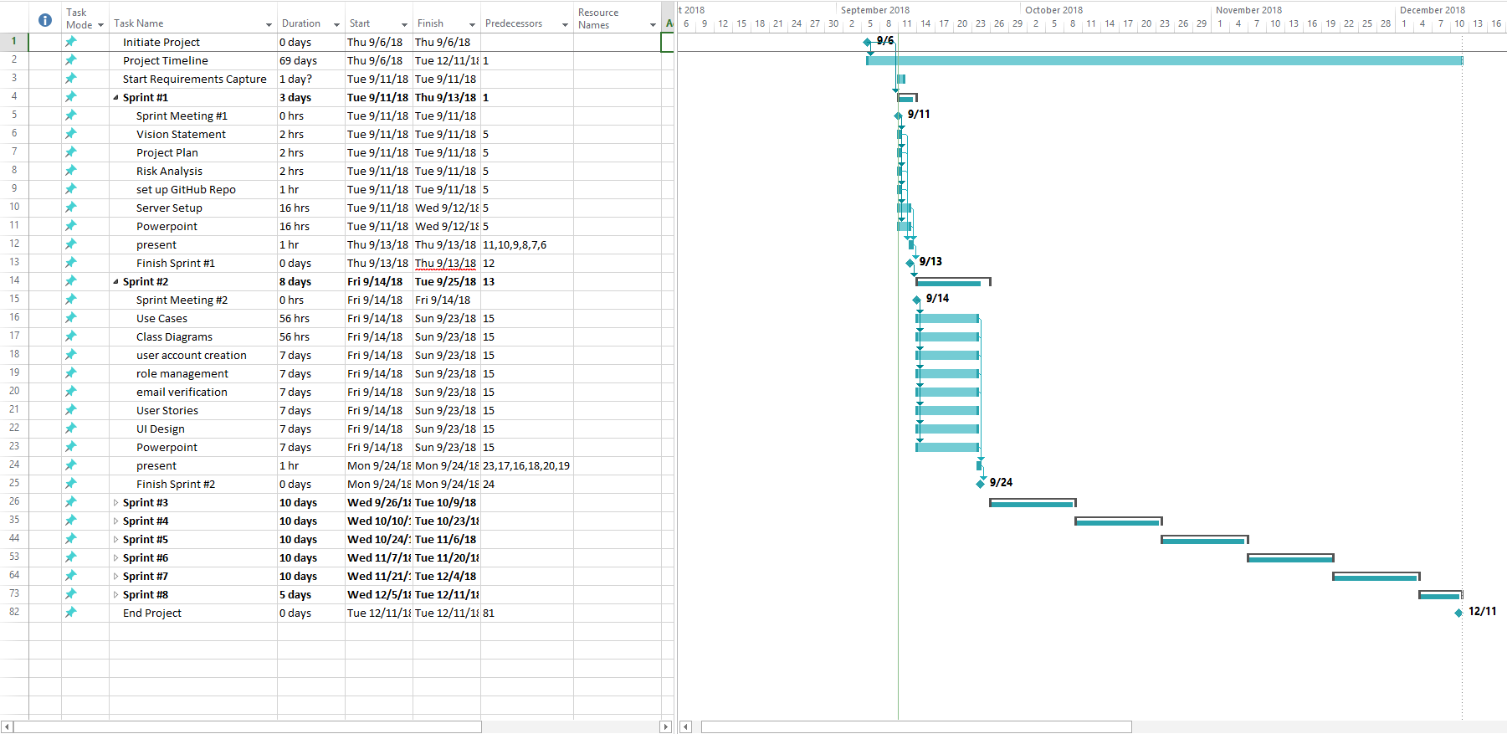

1. *Project Description*

**A. Functional Requirements**

|  |  |  |
| --- | --- | --- |
| Requirement Number | Priority | Requirement |
| REQ1 | 1 | The system shall use the device camera to run OpenCV libraries |
| REQ2 | 2 | The system shall recognize faces seen by the device camera |
| REQ3 | 5 | The system shall use TTS via device audio output to say the name of the person recognized |
| REQ4 | 4 | The system shall have a web portal |
| REQ5 | 3 | The system shall have an app version that runs on Android and iOS |
| REQ6 | 7 | The system shall have a caretaker portal that can connect to a clients account |
| REQ7 | 6 | The system shall have a way for the client to add many pictures to a Database |
| REQ8 | 8 | The caretaker portal shall have an option to enter pictures for the client’s app. |
| REQ9 | 10 | The system shall have a feature that turns the device’s screen black while in the clients pocket to preserve battery life |
| REQ10 | 9 | The system shall alert the client upon facial recognition. |
| REQ11 | 11 | The system should have a location setting that can be turned on and off to allow a caretaker to see where the client is |

**B. Non-Functional Requirements**

|  |  |  |
| --- | --- | --- |
| Requirement Number | Priority | Requirement |
| NRF1 | 1 | The system shall have a MySQL DB to store images |
| NRF2 | 2 | The system shall have a MySQL DB to store text information. |
| NRF3 | 4 | The system shall be able to send a facial recognition message with TTS data in less than a minute |
| NRF4 | 3 | The system shall have a backend server setup to host necessary applications |
| NRF5 | 5 | The system shall have some sort of security |

**C. User Stories**

|  |  |  |  |
| --- | --- | --- | --- |
| Identifier | User Story | Size | Priority |
|  |  |  |  |
|  |  |  |  |
|  |  |  |  |
|  |  |  |  |
|  |  |  |  |
|  |  |  |  |

1. *Design*

**A. Use Cases**

**B. Use Case Specifications**

**UC-1**

Actor: